Accessibility ID Report — RoomSelect
Date: 28.06.2026 20:41 | Platform: ANDROID

Element ID | Page | Type | Label / Text | Value | Resource ID | Status | New Status | AI Suggestion
RoomSelect_element_1 | RoomSelect - Scan 1 | ViewGroup |  |  | facet_with_bui_booking_header_toolbar | Unique ID |  | {  "key": "facetWithBuiBookingHeaderToolbarContainer",  "androidValue": "facet_with_bui_booking_header_toolbar",  "androidType": "id",  "iosValue": "facet_with_bui_booking_header_toolbar",  "iosType": "accessibilityId"  }
RoomSelect_element_2 | RoomSelect - Scan 1 | TextView | 1 | 1 | bubble | Unique ID |  | {  "key": "bubbleLabel",  "androidValue": "bubble",  "androidType": "id",  "iosValue": "bubble",  "iosType": "accessibilityId"  }
RoomSelect_element_3 | RoomSelect - Scan 1 | TextView | Search | Search | navigation_bar_item_large_label_view | Unique ID |  | {  "key": "navigationBarItemLargeLabelViewLabel",  "androidValue": "navigation_bar_item_large_label_view",  "androidType": "id",  "iosValue": "navigation_bar_item_large_label_view",  "iosType": "accessibilityId"  }
RoomSelect_element_4 | RoomSelect - Scan 2 | View |  |  | sr_list | Unique ID |  | {  "key": "srListContainer",  "androidValue": "sr_list",  "androidType": "id",  "iosValue": "sr_list",  "iosType": "accessibilityId"  }
RoomSelect_element_5 | RoomSelect - Scan 2 | ViewGroup |  |  | sr_activity_root | Unique ID |  | {  "key": "srActivityRootContainer",  "androidValue": "sr_activity_root",  "androidType": "id",  "iosValue": "sr_activity_root",  "iosType": "accessibilityId"  }
RoomSelect_element_6 | RoomSelect - Scan 2 | ViewGroup |  |  | sr_toolbar | Unique ID |  | {  "key": "srToolbarContainer",  "androidValue": "sr_toolbar",  "androidType": "id",  "iosValue": "sr_toolbar",  "iosType": "accessibilityId"  }
RoomSelect_element_7 | RoomSelect - Scan 2 | TextView | Paris | Paris | searchbox_destination | Unique ID |  | {  "key": "searchboxDestinationLabel",  "androidValue": "searchbox_destination",  "androidType": "id",  "iosValue": "searchbox_destination",  "iosType": "accessibilityId"  }
RoomSelect_element_8 | RoomSelect - Scan 2 | TextView | · | · | searchbox_separator | Unique ID |  | {  "key": "searchboxSeparatorLabel",  "androidValue": "searchbox_separator",  "androidType": "id",  "iosValue": "searchbox_separator",  "iosType": "accessibilityId"  }
RoomSelect_element_9 | RoomSelect - Scan 2 | TextView | 28 Jun - 29 Jun | 28 Jun - 29 Jun | searchbox_dates | Unique ID |  | {  "key": "searchboxDatesLabel",  "androidValue": "searchbox_dates",  "androidType": "id",  "iosValue": "searchbox_dates",  "iosType": "accessibilityId"  }
RoomSelect_element_10 | RoomSelect - Scan 3 | Button | Select rooms | Select rooms | select_room_cta | Unique ID |  | {  "key": "selectRoomCtaBtn",  "androidValue": "select_room_cta",  "androidType": "id",  "iosValue": "select_room_cta",  "iosType": "accessibilityId"  }
RoomSelect_element_11 | RoomSelect - Scan 3 | ViewGroup |  |  | facet_with_bui_booking_header_toolbar | Unique ID |  | {  "key": "facetWithBuiBookingHeaderToolbarContainer",  "androidValue": "facet_with_bui_booking_header_toolbar",  "androidType": "id",  "iosValue": "facet_with_bui_booking_header_toolbar",  "iosType": "accessibilityId"  }
RoomSelect_element_12 | RoomSelect - Scan 3 | ViewGroup |  |  | facet_with_bui_booking_header_content | Unique ID |  | {  "key": "facetWithBuiBookingHeaderContentContainer",  "androidValue": "facet_with_bui_booking_header_content",  "androidType": "id",  "iosValue": "facet_with_bui_booking_header_content",  "iosType": "accessibilityId"  }
RoomSelect_element_13 | RoomSelect - Scan 3 | ViewGroup | Review score of 6.0 out of 10 |  | property_review_score | Unique ID |  | {  "key": "propertyReviewScoreContainer",  "androidValue": "property_review_score",  "androidType": "id",  "iosValue": "property_review_score",  "iosType": "accessibilityId"  }
RoomSelect_element_14 | RoomSelect - Scan 3 | TextView | Grand Hôtel De L'Europe  ​​ | Grand Hôtel De L'Europe  ​​ | property_name | Unique ID |  | {  "key": "propertyNameLabel",  "androidValue": "property_name",  "androidType": "id",  "iosValue": "property_name",  "iosType": "accessibilityId"  }
RoomSelect_element_15 | RoomSelect - Scan 3 | TextView | 6.0 | 6.0 | bui_review_score_view | Unique ID |  | {  "key": "buiReviewScoreViewLabel",  "androidValue": "bui_review_score_view",  "androidType": "id",  "iosValue": "bui_review_score_view",  "iosType": "accessibilityId"  }
RoomSelect_element_16 | RoomSelect - Scan 4 | Button | Share hotel |  | menu_share_hotel | Unique ID |  | {  "key": "menuShareHotelBtn",  "androidValue": "menu_share_hotel",  "androidType": "id",  "iosValue": "menu_share_hotel",  "iosType": "accessibilityId"  }
RoomSelect_element_17 | RoomSelect - Scan 4 | ViewGroup |  |  | decor_content_parent | Unique ID |  | {  "key": "decorContentParentContainer",  "androidValue": "decor_content_parent",  "androidType": "id",  "iosValue": "decor_content_parent",  "iosType": "accessibilityId"  }
RoomSelect_element_18 | RoomSelect - Scan 4 | ViewGroup |  |  | action_bar | Unique ID |  | {  "key": "actionBarContainer",  "androidValue": "action_bar",  "androidType": "id",  "iosValue": "action_bar",  "iosType": "accessibilityId"  }
RoomSelect_element_19 | RoomSelect - Scan 4 | RelativeLayout |  |  | room_list_root | Unique ID |  | {  "key": "roomListRootContainer",  "androidValue": "room_list_root",  "androidType": "id",  "iosValue": "room_list_root",  "iosType": "accessibilityId"  }
RoomSelect_element_20 | RoomSelect - Scan 1 | ImageView |  |  | facet_entry_point_item_icon | Duplicate ID | ID Must Be Added (Waiting Dev) | imageview_icon
RoomSelect_element_21 | RoomSelect - Scan 1 | ImageView |  |  | facet_entry_point_item_icon | Duplicate ID | ID Must Be Added (Waiting Dev) | imageview_icon
RoomSelect_element_22 | RoomSelect - Scan 1 | ImageView |  |  | facet_entry_point_item_icon | Duplicate ID | ID Must Be Added (Waiting Dev) | imageview_icon
RoomSelect_element_23 | RoomSelect - Scan 1 | ImageView |  |  | facet_entry_point_item_icon | Duplicate ID | ID Must Be Added (Waiting Dev) | imageview_icon
RoomSelect_element_24 | RoomSelect - Scan 1 | ImageView |  |  | navigation_bar_item_icon_view | Duplicate ID | ID Must Be Added (Waiting Dev) | imageview_icon
RoomSelect_element_25 | RoomSelect - Scan 1 | ImageView |  |  | navigation_bar_item_icon_view | Duplicate ID | ID Must Be Added (Waiting Dev) | imageview_icon
RoomSelect_element_26 | RoomSelect - Scan 1 | ImageView |  |  | navigation_bar_item_icon_view | Duplicate ID | ID Must Be Added (Waiting Dev) | imageview_icon
RoomSelect_element_27 | RoomSelect - Scan 1 | ImageView |  |  | navigation_bar_item_icon_view | Duplicate ID | ID Must Be Added (Waiting Dev) | imageview_icon
RoomSelect_element_28 | RoomSelect - Scan 1 | TextView | Stays | Stays | facet_entry_point_item_label | Duplicate ID | ID Must Be Added (Waiting Dev) | stays_label
RoomSelect_element_29 | RoomSelect - Scan 1 | TextView | Car rental | Car rental | facet_entry_point_item_label | Duplicate ID | ID Must Be Added (Waiting Dev) | car_rental_label
RoomSelect_element_30 | RoomSelect - Scan 1 | TextView | Taxi | Taxi | facet_entry_point_item_label | Duplicate ID | ID Must Be Added (Waiting Dev) | taxi_label
RoomSelect_element_31 | RoomSelect - Scan 1 | TextView | Attractions | Attractions | facet_entry_point_item_label | Duplicate ID | ID Must Be Added (Waiting Dev) | attractions_label
RoomSelect_element_32 | RoomSelect - Scan 1 | TextView | Saved | Saved | navigation_bar_item_small_label_view | Duplicate ID | ID Must Be Added (Waiting Dev) | saved_label
RoomSelect_element_33 | RoomSelect - Scan 1 | TextView | Bookings | Bookings | navigation_bar_item_small_label_view | Duplicate ID | ID Must Be Added (Waiting Dev) | bookings_label
RoomSelect_element_34 | RoomSelect - Scan 1 | TextView | My account | My account | navigation_bar_item_small_label_view | Duplicate ID | ID Must Be Added (Waiting Dev) | my_account_label
RoomSelect_element_35 | RoomSelect - Scan 2 | ImageView | Save property to list |  | wl_icon | Duplicate ID | ID Must Be Added (Waiting Dev) | save_property_to_list_icon
RoomSelect_element_36 | RoomSelect - Scan 2 | ImageView | Save property to list |  | wl_icon | Duplicate ID | ID Must Be Added (Waiting Dev) | save_property_to_list_icon
RoomSelect_element_37 | RoomSelect - Scan 2 | ImageView | Save property to list |  | wl_icon | Duplicate ID | ID Must Be Added (Waiting Dev) | save_property_to_list_icon
RoomSelect_element_38 | RoomSelect - Scan 1 | Button | Paris |  |  | Missing ID | ID Must Be Added (Waiting Dev) | paris_btn
RoomSelect_element_39 | RoomSelect - Scan 1 | Button | Staying from Sun 28 Jun until Mon 29 Jun |  |  | Missing ID | ID Must Be Added (Waiting Dev) | staying_from_sun_28_jun_until_mon_29_jun_btn
RoomSelect_element_40 | RoomSelect - Scan 1 | Button | 1 room, 2 adults, 0 children |  |  | Missing ID | ID Must Be Added (Waiting Dev) | 1_room_2_adults_0_children_btn
RoomSelect_element_41 | RoomSelect - Scan 1 | ImageView | Messages |  |  | Missing ID | ID Must Be Added (Waiting Dev) | messages_icon
RoomSelect_element_42 | RoomSelect - Scan 1 | ImageView | Notifications |  |  | Missing ID | ID Must Be Added (Waiting Dev) | notifications_icon
RoomSelect_element_43 | RoomSelect - Scan 2 | ImageButton | Navigate up |  |  | Missing ID | ID Must Be Added (Waiting Dev) | navigate_up_btn
RoomSelect_element_44 | RoomSelect - Scan 3 | ImageButton | Navigate up |  |  | Missing ID | ID Must Be Added (Waiting Dev) | navigate_up_btn
RoomSelect_element_45 | RoomSelect - Scan 3 | ImageView | Add to wish list |  |  | Missing ID | ID Must Be Added (Waiting Dev) | add_to_wish_list_icon
RoomSelect_element_46 | RoomSelect - Scan 3 | ImageView | Share hotel |  |  | Missing ID | ID Must Be Added (Waiting Dev) | share_hotel_icon
RoomSelect_element_47 | RoomSelect - Scan 4 | ImageButton | Navigate up |  |  | Missing ID | ID Must Be Added (Waiting Dev) | navigate_up_btn

📸 Screenshot
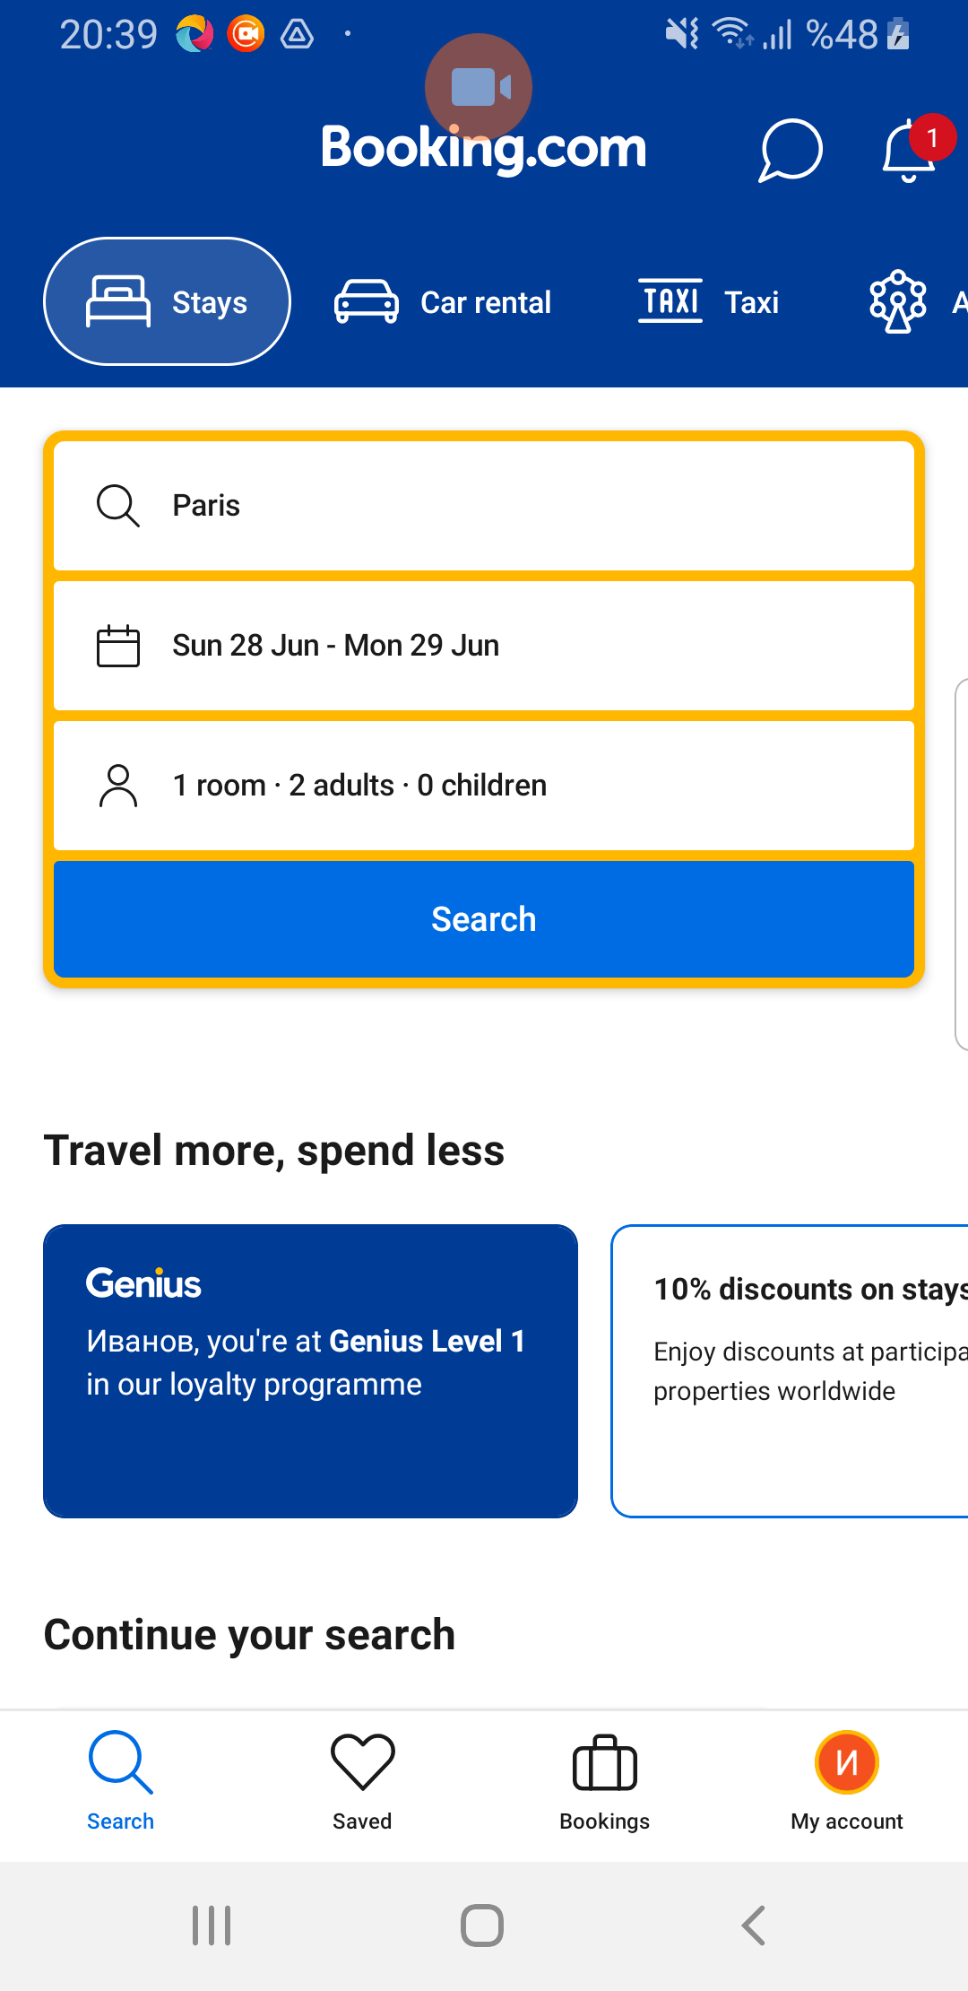
RoomSelect page screenshot

